Name _______________________________ Fiber Notes
Period ____ Date _____________________ Forensics

- Fiber – the smallest indivisible unit of a textile (cloth or woven fabric)
  - It must be at least 100 times longer than it is wide to be considered a fiber
  - Fibers are used to create links between crimes and suspects
  - Fibers are a form of trace evidence.
  - Fibers can come from carpets, clothing, linens, furniture, insulation or rope.
  - Fibers can be directly transferred from a suspect to a victim.
  - Fibers can also be a secondary transfer
    - EX. Victim didn’t touch the towel but the suspect had towel fibers on him because he had touched the towel.
  - Fibers must be collected early.
  - 95% of fibers fall off within 24 hours.
  - Only fibers that you would not expect to find would be examined.
Questions that Forensics Scientists ask about fiber.
- What type of fiber is it?
- Is it a common fiber or a rare fiber?
- What color is the fiber?
- What kind of dyes are in the fiber?
- Do the fibers match clothes? Carpets? Ropes?
- How many fibers were found?
  - More fibers are found with more contact?
- Where was the fiber found?
- How many different types of fiber were found?
- What type of crime was committed? To determine a possible pattern of fiber transfer.
- How much time has passed between the crime and discovery?

Fiber Collection
- Special vacuums, sticky tape, scrapers and forceps are used to collect fibers.
- If only one fiber is found:
  - Polarizing light microscopy can be used for natural fibers.
  - Infrared light microscopy can be used for synthetic fibers.
  - The fiber should not be altered or damaged
    - since it’s the only piece of fiber evidence, if it’s altered or damaged as the CSI studies it – the results will not be able to be used in court.
- If large amounts of fibers are found
  - CSI investigators can alter and destroy some as they study the fibers
    - Flame Test – certain fibers burn in different ways
    - Dissolving the fibers in various liquids to see what the fibers might be made out of.

Fibers vs. Textiles
- Textiles are clothing, carpet, upholstery… that are constructed by weaving or intertwining yarns.
- Textiles are made up of fibers.
- Yarns – made of fibers spun together

Classification of Fiber
- Natural fibers can come from animals, plants and minerals (that are mined from the ground).
  - Animal fibers are from hair, fur and webbing
    - Animal fibers are made of proteins
    - Fur – coats, gloves, hats…
    - Hair – is easily spun into clothes, comes out easily and regrows
      - Wool – from sheep * most common fiber
      - Camel
      - Angora Rabbit
      - Mohair goats
      - Cashmere goats
    - Webbing
      - Silk is collected from a cocoon of a caterpillar, Bombyx mari. Fibers are long and do not shed as much.
  - Plant fibers come from seeds, fruit, stems and leaves
    - Plant fibers are made from cellulose – a type of glucose that resists damage and is not soluble in water
      - * plant fibers are not made of protein like animal fibers are.
    - Cotton is the most common plant fiber used in textiles
      - Cotton fibers are often short (2-5cm) and become brittle.
      - Cotton is found in the seed pod.
      - Cotton can be easily woven and dyed.

    - Fruit Fibers
      - Coir – coarse fiber obtained from the covering surrounding coconuts.
        - It is waterproof
        - It is found in baskets and doormats.
    - Stem Fibers – Grow in bundles and are beaten, rolled and washed until they separate into single fibers.
      - Flax – most common
        - Found in linen, pants, jackets and table clothes
        - Flax is unique because it is dense and crystalline and resists rot and damage
      - Jute – mopes mats and handbags
      - Hemp - used in Asia for clothing
        - It has become popular in North America as an alternative to cotton.
    - Leaf Fibers
      - Manila fiber is extracted from abaca leaves in long fibers. It is a relative to bananas.
      - Sisal fibers are from a desert succulent.
        - It deteriorates easily.
        - It is used in making rope and twine

Synthetic Fibers are man-made.
- Synthetic fibers have no definite size or shape and are easy to dye.
- Using a polarizing microscope synthetic fibers
  - Have very regular diameters
  - Have no internal structures
  - May be hollow, solid and/or twisted
- Synthetic fibers are either regenerated natural fibers or polymers that come from petroleum products.

  - Regenerated fibers are modified natural fibers made by altering the cellulose.
    - Examples:
        - Rayon is used in clothing
        - Celanese is used in carpeting
        - Capron is used in high performance clothing.
  - Polymers are large molecules that are made up of many subunits.
    - Monomers are small molecules that may bond to other monomers to become a polymer.
Types of Synthetic Fiber
      - Polyester
        - Very common
        - Used in fleece, pants and shirts
        - Can be added to cotton for strength
        - Not easily broken down
2. Nylon
a. similar to polyester except that it is easily broken down by
light and acid
b. commonly found in pantyhose.
3. Acrylic
a. used in artificial wool and imitation fur
b. light fluffy feel
c. can “ball” or “pill” easily
d. cheap
4. Olefins
a. used in high-performance clothing, thermal socks, carpet
b. they are quick drying and resistant to wear
Natural Fibers | Synthetic Fibers
Weaker | Stronger
Damaged by organisms (insects) | Not usually damaged by insects
Do not breakdown in sunlight | Break down in sunlight
Do not melt as easily | Melts easily
Made of protein or cellulose | Made from petroleum and chemicals
Internal structures can be seen using a microscope | Can not see internal structures
Have been used for 1000’s years | Have been common from 50+ years

Fiber | Characteristics seen under magnification
Cotton | - “Flattened hose” appearance  - Up to 2 inches long  - May have a frayed “root”  - Hollow core not always visible
Flax | - “bamboo stick” appearance  - Straight with angles but not very curved  - “nodes” are visible an and X every inch  - Often occur in bundles of several fibers
Silk | - Do not taper  - Show small variations in diameter  - May be paired with another fiber  - No internal structures are visible
Wool | - Surface scales may be visible  - Hollow or partially hollow core  - Fibers up to 3 inches long  - Fibers taper to a point
Synthetic | - Vary widely in cross-sectional shape and diameter  - Generally straight to gentle curves  - Very uniform in diameter  - May have surface treatment that appears as spots, stains or pits

Yarn is fiber that is made of many shorter fibers that have been spun together
- Rope is a big piece of yarn.
- Yarn can be thick or thin, loose or tight.
- Yarn can be made of anything.
- Yarn has a twist direction that can be identified by forensic scientists.

Textiles are flexible, flat material made by interlacing yarns or threads.
- During the Stone Age – Flax was woven into linen.
- The oldest loom is dated to be 4400 BC.
- Weaving consists of arranging lengthwise threads (warp) side-by-side close together.
- Crosswise threads (weft) are then woven back and forth.

Type of Weave | Diagram | Description | Characteristics
Plain | 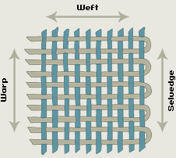 | Alternating warp and weft threads | - Firm and wears well  - Snag resistant  - Low tear strength  - Tends to wrinkle
Basket | 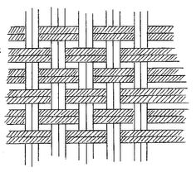 | Alternating pattern of two weft threads crossing two warp threads | - An open or porous weave  - Does not wrinkle  - Not very durable  - Tends to distort as yarns shift  - Shrinks when washed
Satin | 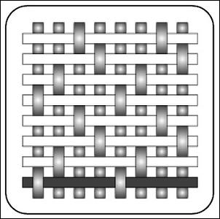 | One weft crosses over three or more warp threads. | - Not durable  - Tends to snag and break during wear  - Shiny surface  - High light reflectance  - Little friction with other garments
Twill | 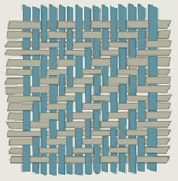 | Weft is woven over three or more warps and then under one. Next row, the pattern is shifted over one to the left or right by one warp thread | - Very strong  - Dense and compact  - Different faces  - Diagonal design on surface  - Soft and pliable
Leno | 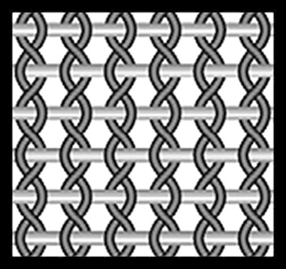 | This uses two warp threads and a double weft thread. The two adjacent warp threads cross over each other. The weft travels left or right and is woven between the two warp threads. | - Open weave  - Easily distorted with wear and washing  - Stretches in one direction only

